SQL Project – Atliq Hardware

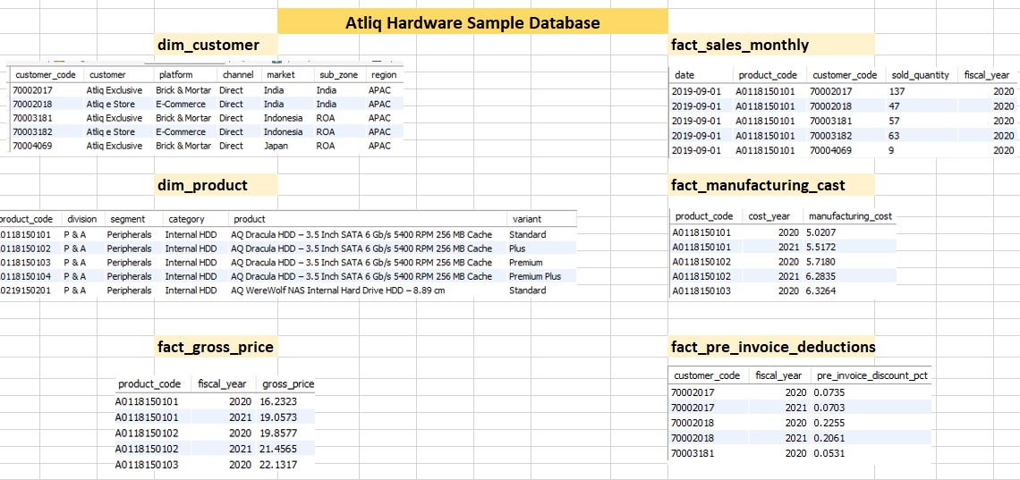

**SQL Reports (Think to get insights from individual table)**

**dim_customer**

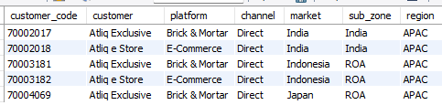

1. Get customer base count for Atliq Hardware?

**SQL >>** SELECT

COUNT(DISTINCT customer) as total_customer

FROM dim_customer;



1. What are different platforms/channels that Atliq Hardware business is happening?

**SQL>>** SELECT

distinct(customer) as customer,

market

from dim_customer

where channel = "retailer";

1. What are different platforms/channels that Atliq Hardware business happening
2. List down the Market places / Zones / Regions the business expanded
3. Generate a report of - Top/Bottom ranked customers by Market and Channel

**SQL >>** WITH cte1 AS (

SLECT

DISCTINCT(customer) as customer,

market

FROM dim_customer

WHERE channel = "retailer"

)

SELECT

market,

count(market) as customer_count_by_market

FROM cte1

GROUP BY market

ORDER BY customer_count_by_market DESC

LIMIT 5;

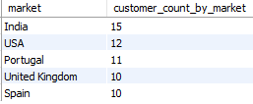

1. How many markets have distributer/direct channel?

**SQL >>** SELECT

distinct market

FROM dim_customer

WHERE channel = "distributor"

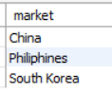

**dim_product**

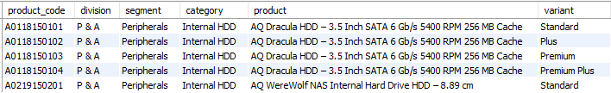

Report Ask (Individual table):

1. Which product category has most/least product list?

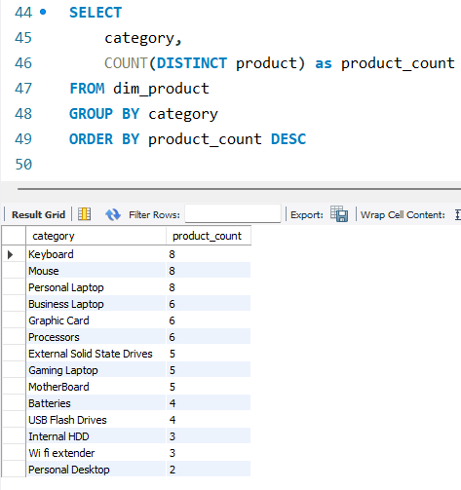

1. Report how many products has maximum variant along with variant count?

SQL>>

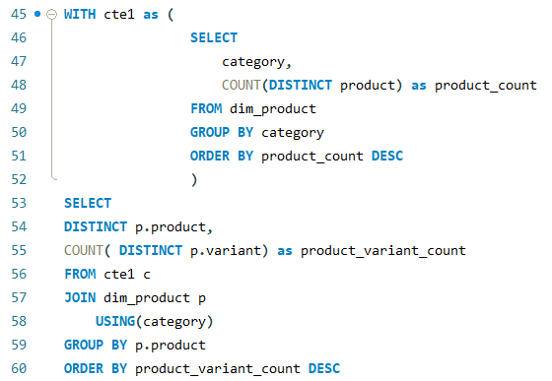

**fact_manufacturing_cost**

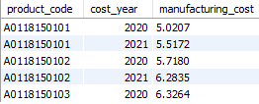

Report Ask:

1. List down Top/Bottom 5 products whose manufacturing cost is maximum/minimum respectively for a given FY

SQL>>

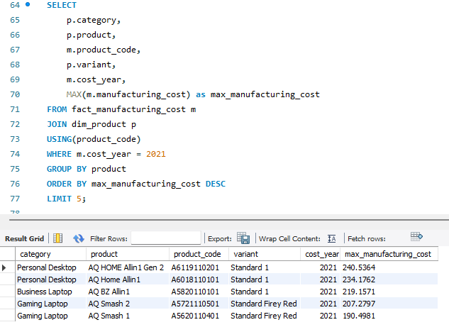

1. Write a procedure to report : get products manufacturing cost for each FY and compare the trend.
2. For how many products, manufacturing cost increased YOY and by how much % change in cost

SQL >>

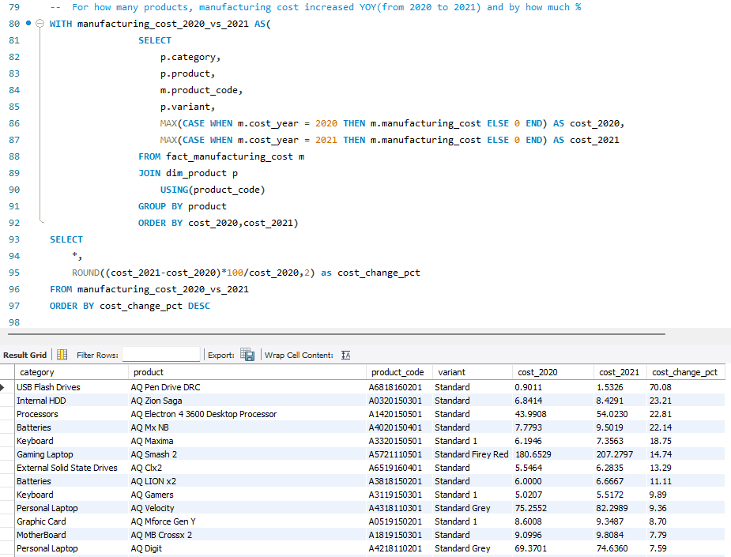

1. Average manufacturing cost for given category/segment/division

SQL:

Below query shows AVG cost for category

